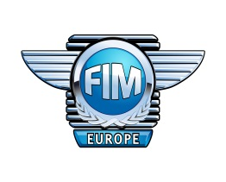

Motorcycle Tour – Assistant (TA) Candidate Check-list

PERSONAL INFORMATION
Name: |  |  | E-mail:
FMN: |  |  | Phone:

PREVIOUS TOURING EXPERIENCE
Inexperienced in Group Touring.
Experienced in Group Touring; if yes: number of years ……………………

LANGUAGE PROFICIENCY
English (fluent / moderate / basic)  German (fluent / moderate / basic) | Spanish (fluent / moderate / basic)  French (fluent / moderate / basic) | Other …………………………………….  (fluent / moderate / basic)  Other …………………………………….  (fluent / moderate / basic)

BASIC PROFICIENCY
Motorcycle riding experience  Technical/maintenance skills  First-aid certificate  Road-side assistance skills | - Number of years: ………………….  - Yes / No  - Yes / No  - Yes / No

A BRIEF OVERVIEW OF TOURS DONE, if any:

INDIVIDUAL CHARACTERISTICS (describe your motivation and social capabilities to become a TA)

ORGANIZATIONAL
Preferable Trainer/FMN where to attend the training:  (the list of Trainers and countries available on fim-europe.com) | ………………………………………………………………………………………………
Start date: ……………………………………………………………………………………………………

Please mail your check-list to FIM Europe General Secretariat:
office@fim-europe.com
within 11th March 2018

